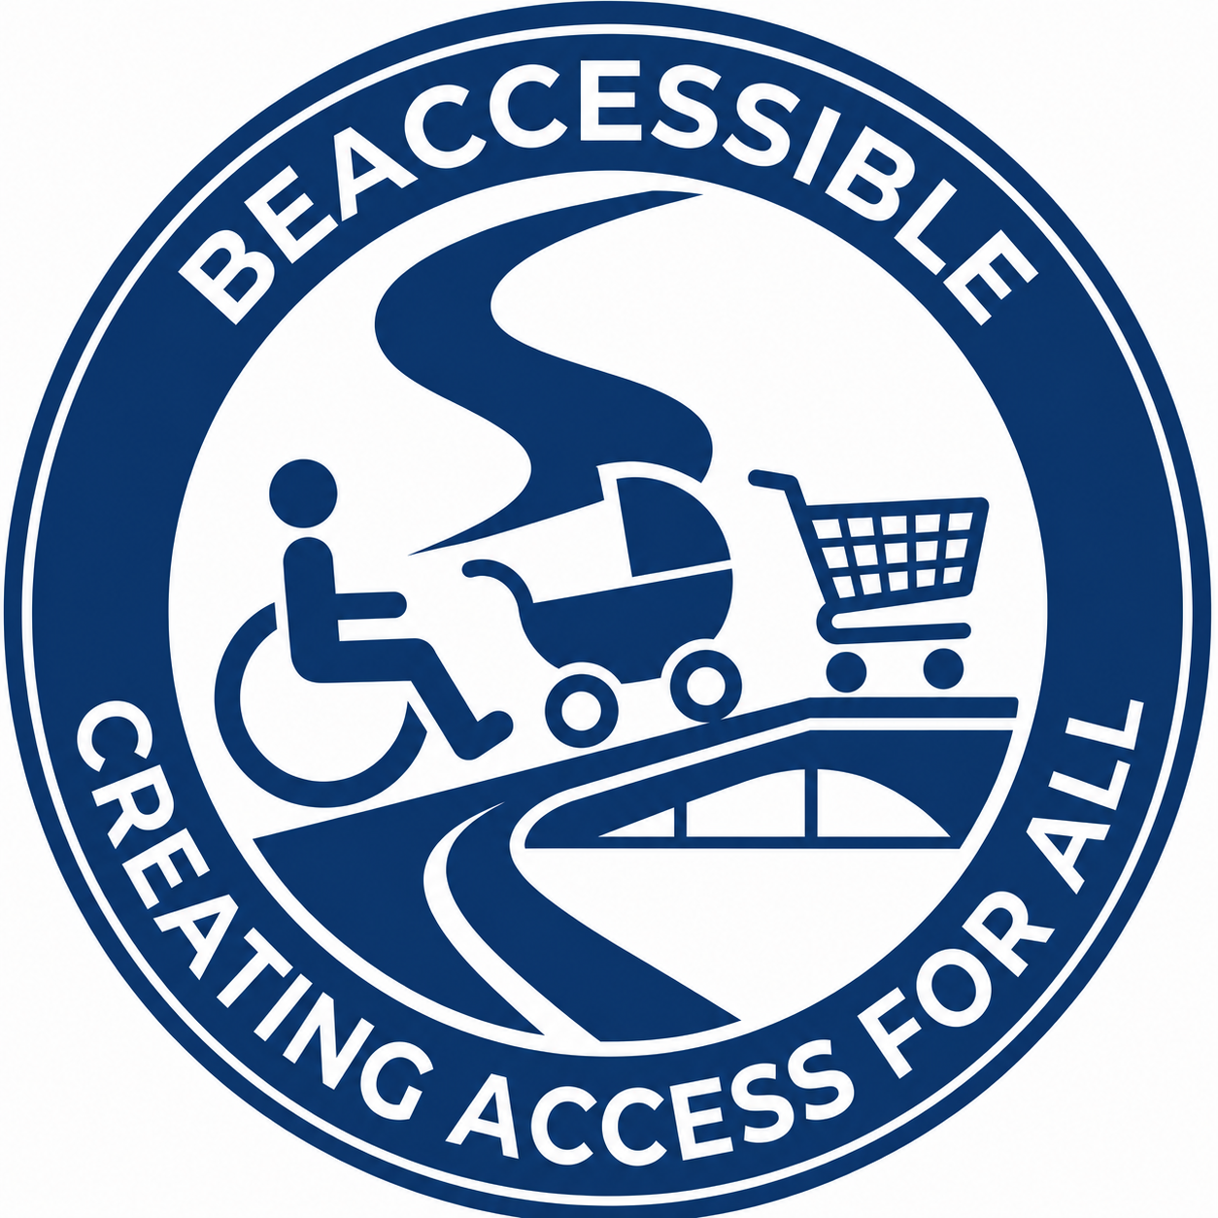
Cover Letter
Proposal for Inclusive Learning Design & Content Development Services
Submitted by BeAccessible (Pty) Ltd

28 August 2026
Girl Effect Procurement Team
Subject: Proposal for Content Writing Consultancy - Content Writer-August 2026
Dear Girl Effect Procurement Team,
BeAccessible (Pty) Ltd is pleased to submit this proposal in response to Girl Effect India’s Request for Proposal for a Content Writing Consultancy.
We understand that this assignment requires more than strong writing. It requires the design of inclusive, engaging and culturally adaptable learning experiences that support adolescent girls and young women to build knowledge, confidence and practical skills.
BeAccessible is an international consulting and technology company specialising in inclusive AI, accessibility, Universal Design, digital transformation, learning design and evidence-based inclusion. Our work combines learning design, behaviour-change communication, accessibility by design and AI-assisted quality assurance to create learning experiences that are understandable, participatory and adaptable across contexts.
Although BeAccessible has not previously implemented projects in India, our methodology is explicitly designed for localisation and collaborative adaptation. We will work closely with Girl Effect’s programme team, content specialists and local experts to ensure that content remains culturally relevant, translation-ready and aligned with Girl Effect’s safeguarding and programme principles.
Our proposed daily professional fee is INR 35,000, with a monthly equivalent of INR 700,000 based on 20 billable days. The proposal is valid for 90 days from the bid closure date.
We would welcome the opportunity to partner with Girl Effect to develop accessible, youth-centred and behaviour-change focused learning content that helps young women realise their potential and shape their own futures.
Yours sincerely,
Fadila Lagadien, MBA
Founder & Executive Director
BeAccessible (Pty) Ltd
hello@beaccessible.co.za
beaccessible.co.za

Accessibility Compliance Note
This document applies BeAccessible accessibility requirements: structured headings, logical reading order, high-contrast colour use, readable typography, accessible tables with header rows, meaningful links and no colour-only communication. WCAG 2.2 Level AAA is targeted where practical for document format limitations.

