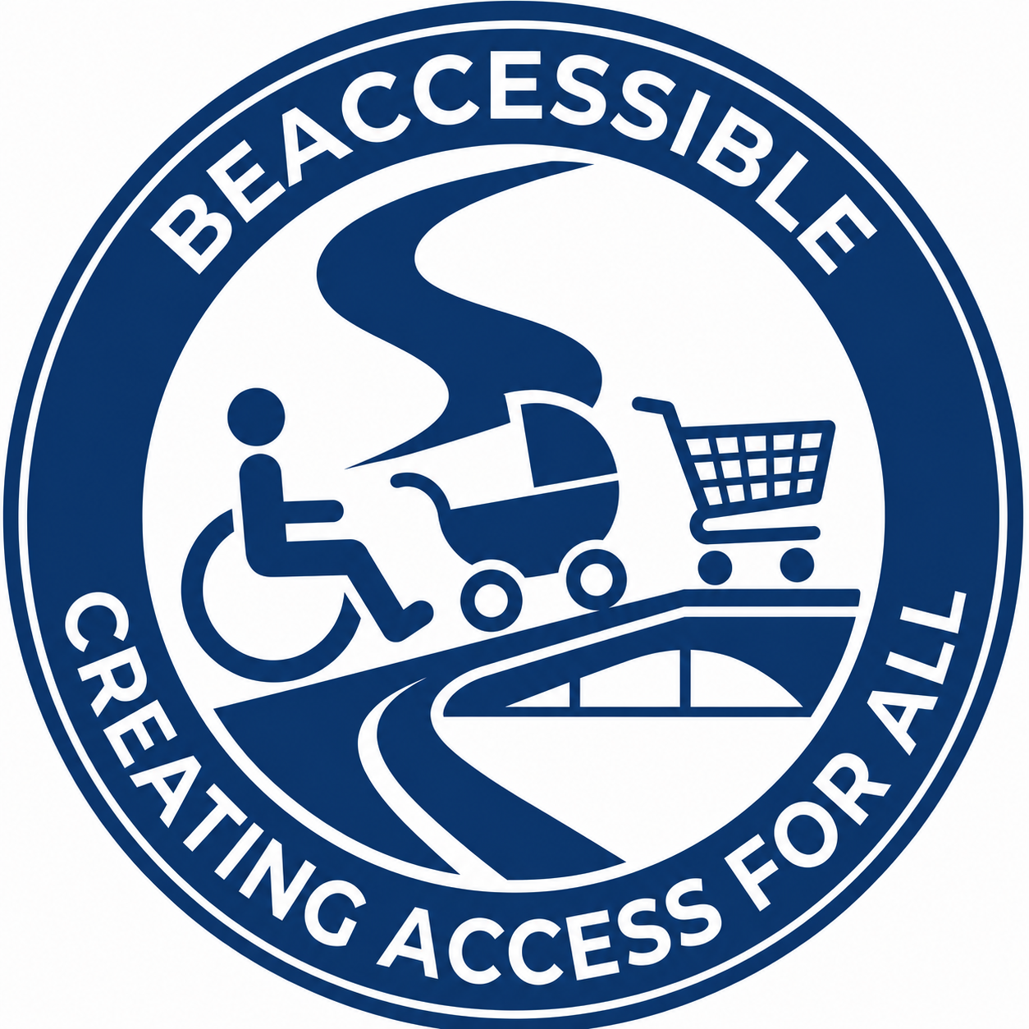
Financial Proposal
Girl Effect Content Writing Consultancy
Submitted by BeAccessible (Pty) Ltd

Commercial Summary
The financial proposal below is submitted separately from the technical proposal. Rates are presented in Indian Rupees (INR).
Line Item | Rate / Assumption | Quantity | Total (INR)
Daily professional fee | INR 35,000 | 1 day | INR 35,000
Monthly equivalent | INR 35,000 per day | 20 billable days | INR 700,000
Estimated duration | 4-5 months | Timeline-based project | Billed against approved workplan
Proposal validity | 90 days | From bid closure | Valid as stated

Inclusions
- Inclusive learning design and content planning
- Multimedia scripts, chatbot conversations, activities and facilitator guidance as agreed in the workplan
- Accessibility and Universal Design review
- AI-assisted quality assurance under human review
- Revision cycles based on agreed review windows
- Collaboration with Girl Effect programme and content teams

Assumptions
- Rates exclude applicable taxes unless otherwise required by local jurisdiction.
- Travel, workshops or in-person activities are excluded unless separately agreed in writing.
- Translation, localisation and subject matter validation will be coordinated with Girl Effect and local specialists.
- Final billing will align with the agreed workplan, approved deliverables and actual days worked.

Accessibility Compliance Note
Structured headings, logical reading order, accessible table headers, high-contrast BeAccessible colours and non-colour-only communication have been applied. WCAG 2.2 Level AAA is targeted where practical for document limitations.

