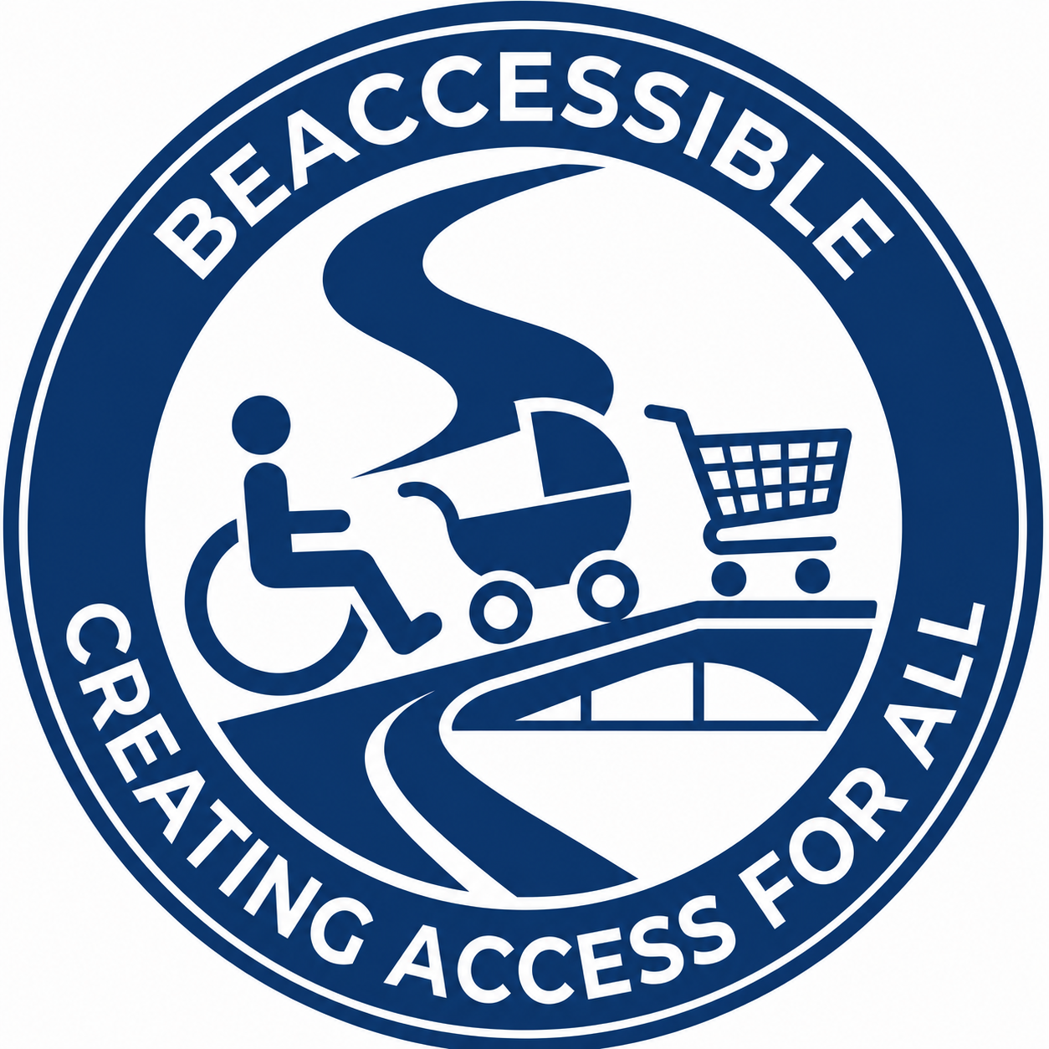

Reference Sheet
Three Confirmed Contactable Referees
Submitted by BeAccessible (Pty) Ltd
Confirmation status: The following referees have confirmed that they are willing to be contacted in support of BeAccessible’s proposal to Girl Effect for the Content Writing Consultancy.

1. Ms Lidia Pretorius
Position / Organisation | Disability Inclusion Strategist / Senior Advisor
Relationship to BeAccessible | Previous colleague / consultant collaborator
Contact status | Confirmed and contactable
WhatsApp | +27 65 521 1119
Email | Lidia.Pretorius@outlook.com

2. Dr Thomas Ongolo
Position / Organisation | GIZ / Stakeholder Management
Relationship to BeAccessible | Consultancy project client / stakeholder
Contact status | Confirmed and contactable
WhatsApp | +27 72 798 2874
Email | thomas.ongolo@giz.de; ink.house@outlook.com

3. Mr Daniel Garcia-Cordero
Position / Organisation | Co-founder, Centela Education
Relationship to BeAccessible | Previous tutor
Contact status | Confirmed and contactable
WhatsApp | Not provided
Email | danielgarcia-cordero@centeia.com

Reference Relevance
These referees can speak to BeAccessible’s strengths in disability inclusion, accessibility, stakeholder collaboration, consultancy delivery, learning support, inclusive communication and professional reliability.

Accessibility Compliance Note
WCAG 2.0 / 2.1 / 2.2 Level AAA principles have been applied where practical. This document uses structured headings, logical reading order, high-contrast BeAccessible colour use, readable Arial typography, accessible tables with clear row labels, and no colour-only communication.

