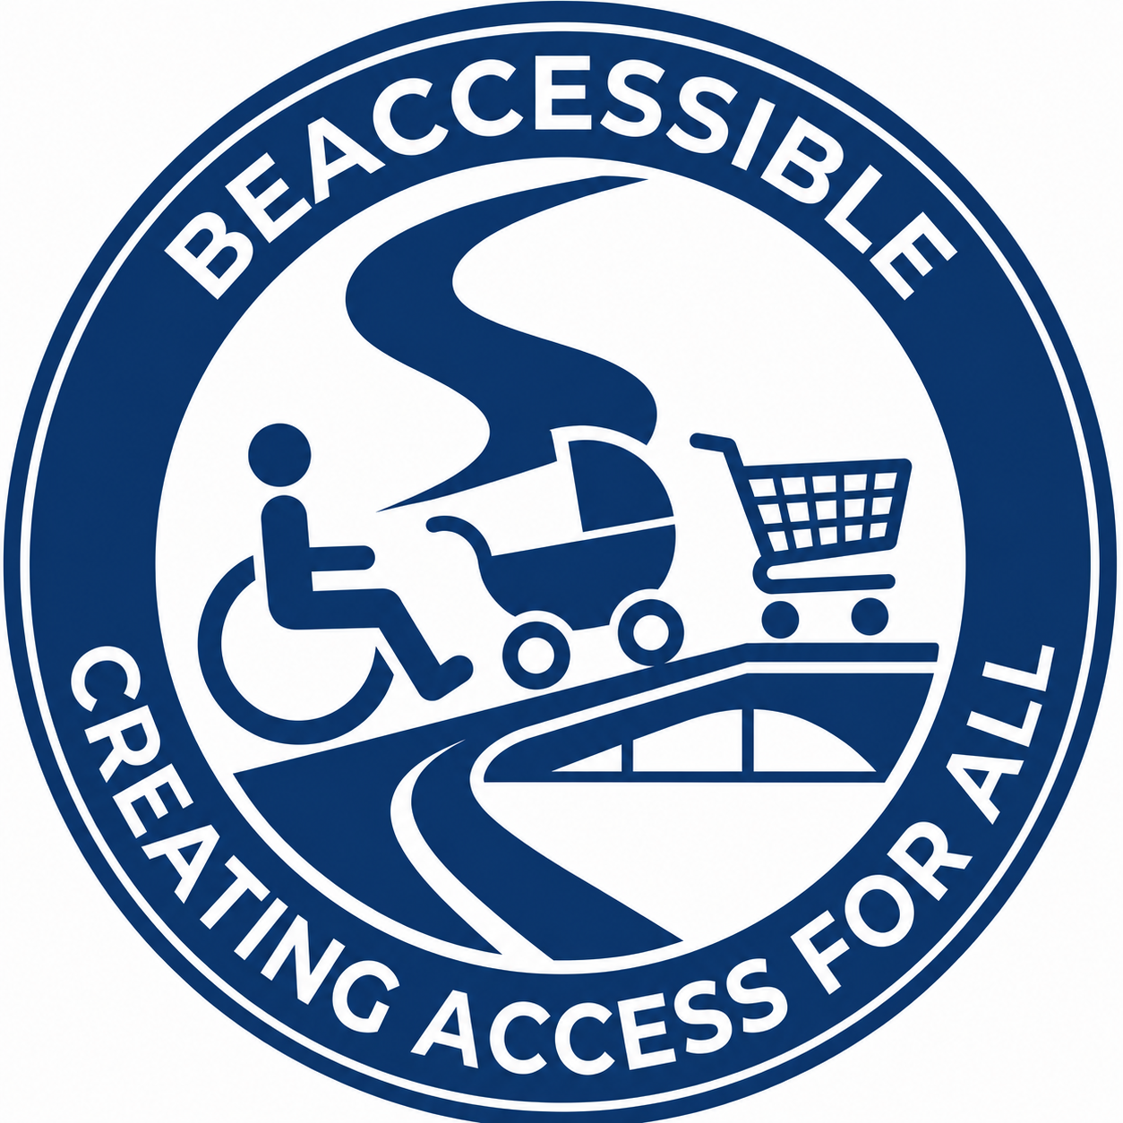
TECHNICAL PROPOSAL
Inclusive Learning Design & Content Development Services
Submitted in response to Girl Effect India
Request for Proposal: Content Writing Consultancy

Submitted by | BeAccessible (Pty) Ltd
Lead | Fadila Lagadien
Title | AI-Enabled Accessibility & Disability Inclusion Specialist
Financial proposal | Submitted separately
Proposal validity | 90 days

Contents
1. Executive Summary
2. About BeAccessible
3. Understanding of the Assignment
4. Inclusive Learning Design Framework™
5. Quality Assurance & Content Excellence Framework
6. Project Management & Delivery Approach
7. Governance & Stakeholder Engagement
8. Relevant Experience & Organisational Capability
9. The BeAccessible Difference
10. Why We Care
11. Accessibility Compliance Note

Executive Summary
BeAccessible is pleased to submit this technical proposal in response to Girl Effect’s Request for Proposal for a Content Writing Consultancy. We recognise that this assignment is not simply about developing educational materials. It is about creating engaging, inclusive and culturally adaptable learning experiences that enable adolescent girls and young women to make informed decisions about their lives.
Our approach combines creative content development with evidence-informed learning design, accessibility, behaviour change communication and inclusive engagement principles. Rather than producing content in isolation, we design learning experiences that encourage participation, reflection, confidence and action.
BeAccessible offers Girl Effect more than content writing. We provide specialist expertise in inclusive learning design, accessibility, Universal Design for Learning, behaviour-change communication and AI-supported educational innovation. These capabilities enable us to produce learning experiences that remain effective across multiple delivery platforms, literacy levels and participant groups.

About BeAccessible
BeAccessible is an international consulting and technology company specialising in inclusive AI, accessibility, Universal Design, digital transformation, learning design and evidence-based inclusion.
We partner with organisations to transform complex information into engaging, practical learning experiences that are accessible, understandable and relevant to diverse audiences. Our work is founded on a simple principle: learning creates impact only when people can access it, understand it and apply it.
We combine expertise in learning design, behaviour change communication, accessibility, Universal Design for Learning and digital innovation to create learning experiences that are inclusive by design rather than adapted afterwards.

Understanding of the Assignment
BeAccessible understands that this consultancy extends far beyond the production of educational content. The assignment requires the design of engaging, youth-centred learning experiences that enable adolescent girls and young women to build knowledge, confidence and practical skills through meaningful participation.
The required outputs - including multimedia scripts, chatbot conversations, facilitator guidance, role plays, interactive activities, quizzes and digital learning experiences - illustrate a programme that values participation over passive information sharing.
Because the proposed learning materials will be adapted into multiple regional languages and delivered through both facilitated and digital environments, content must be intentionally written to support localisation. Our writing methodology therefore prioritises plain language, consistent terminology, logical structure, translation readiness, cultural adaptability and inclusive communication.

Inclusive Learning Design Framework™
For this assignment, BeAccessible will apply its Inclusive Learning Design Framework™, a six-stage methodology that integrates learning design, behaviour-change communication, accessibility, quality assurance and collaborative content development into a single repeatable process.
Stage | Purpose
Discover | Understand programme objectives, audience characteristics, learning barriers, delivery environments, safeguarding requirements and success indicators.
Co-Design | Translate programme objectives into learning journeys, session structures, story concepts, activities, chatbot flows and multimedia concepts.
Create | Develop multimedia scripts, facilitator guides, chatbot conversations, case studies, reflection activities, quizzes, games, role plays and worksheets.
Validate | Review each learning asset for technical accuracy, behaviour-change effectiveness, accessibility, readability, inclusivity, safeguarding and translation readiness.
Adapt | Prepare content for localisation through plain language, consistent terminology, cultural flexibility and collaboration with local specialists.
Refine | Improve resources through structured feedback from Girl Effect, subject matter experts, facilitators, content testing and user insights.

Quality Assurance & Content Excellence Framework
Quality assurance is embedded throughout the assignment rather than treated as a final review activity. Every learning asset will be reviewed through five quality pillars before delivery.
Quality pillar | Review focus
Educational Excellence | Checks that content supports learning objectives, age-appropriate engagement, reflection and practical application.
Behaviour Change Integrity | Ensures resources promote self-efficacy, realistic decision-making, learner confidence and positive norms.
Accessibility & Inclusion | Reviews language, structure, participation methods and delivery formats for diverse learners and disabled participants.
Cultural & Linguistic Readiness | Ensures content is translation-ready, culturally adaptable, consistent in terminology and suitable for localisation.
Technical Accuracy & Safeguarding | Confirms content is evidence-informed, appropriate, respectful, gender-responsive and aligned with safeguarding guidance.
The BeAccessible Quality Promise: Every learning asset is reviewed for educational excellence, behaviour change effectiveness, accessibility, cultural readiness and technical accuracy before delivery.

Project Management & Delivery Approach
BeAccessible will manage the consultancy through clear work cycles, structured review points, disciplined version control and responsive communication with Girl Effect’s programme and content teams.
- Collaboration: Content development is treated as a partnership between BeAccessible, Girl Effect programme specialists, creative teams and local subject matter experts.
- Transparency: Progress, risks, feedback, dependencies and upcoming deliverables are made visible through structured updates and milestone tracking.
- Agility: Learning assets are refined through feedback, content testing and programme learning while maintaining consistency and delivery discipline.
- Quality: Every deliverable progresses through accessibility, safeguarding, readability, technical accuracy and translation-readiness checks.
- Continuous learning: Insights from review cycles and testing are incorporated into subsequent deliverables.

Project delivery lifecycle
Phase | Activities
1. Project initiation | Inception meeting, document review, confirmation of priorities, communication protocols, review cycles and detailed work plan.
2. Learning design | Audience analysis, behaviour-change mapping, session structures, content architecture, learner journeys and story concepts.
3. Content development | Development of multimedia scripts, chatbot conversations, facilitator guides, learner worksheets, role plays, quizzes and interactive activities.
4. Review and refinement | Collaborative review for technical accuracy, learner engagement, accessibility, safeguarding, localisation and consistency.
5. Finalisation | Final quality assurance, formatting, editorial review, accessibility checks and preparation of implementation-ready deliverables.

Governance & Stakeholder Engagement
BeAccessible’s governance model is designed to support shared ownership, structured decision-making, safeguarding awareness and practical knowledge transfer throughout the assignment.
- Collaborative working model: We work closely with programme leads, technical specialists, learning designers, multimedia teams, translators, facilitators and monitoring colleagues where appropriate.
- Feedback management: Review comments are consolidated, decisions are documented, revisions are tracked and unresolved issues are clearly escalated for programme decision-making.
- Safeguarding and ethical practice: Content is developed with careful attention to dignity, privacy, inclusion, age-appropriateness, non-discrimination and Girl Effect’s safeguarding guidance.
- Knowledge transfer: Where appropriate, BeAccessible will share reusable templates, content principles and quality standards that strengthen future learning design work.

Relevant Experience & Organisational Capability
BeAccessible brings together learning design, accessibility, Universal Design for Learning, AI-enabled educational innovation and inclusive communication. The following examples demonstrate capability that is directly relevant to Girl Effect’s requirements.
Project / Initiative | Capability demonstrated | Relevance to Girl Effect
AI-Enabled Inclusive Learning Hub | Designed an accessible online learning ecosystem with structured learner pathways, interactive educational content and AI-assisted learning support. | Supports interactive learning experiences, facilitator resources and digital education content.
AI-Powered Accessibility & Policy Guidance Tools | Developed conversational AI tools that simplify technical information and guide users through practical scenarios. | Supports chatbot conversations, interactive learning products and learner-friendly technical translation.
Inclusive Learning & Universal Design Programmes | Created educational resources using Universal Design for Learning, plain language and accessible resource design. | Aligns with inclusive, accessible content development across literacy levels, disabilities and contexts.
Behaviour Change Through Interactive Learning | Developed scenario-based learning, reflective questions, guided discussions and practical activities. | Supports Girl Effect’s behaviour-change objectives through reflection, confidence and decision-making.
Voice of Disability Initiative | Developed accessible communication resources and public education initiatives that translate complex policy and human rights concepts. | Demonstrates respectful, accessible communication for inclusion and empowerment.

The BeAccessible Difference
- We design learning experiences, not just content: Scripts, guides, activities and chatbot conversations are treated as connected parts of a learner journey.
- Accessibility improves learning for everyone: Clear language, flexible participation and logical structure improve comprehension and participation for all learners.
- Universal Design for Learning: Resources offer multiple ways to engage, understand, participate and demonstrate learning.
- AI as an enabler, never a replacement: AI supports ideation, structure, readability and review while human judgement remains central.
- Designed for local adaptation: Source content is prepared to support translation, localisation and collaboration with Girl Effect’s local specialists.

Why We Care
At BeAccessible, we believe that education is one of the most powerful drivers of opportunity, confidence and long-term social change. However, learning can only achieve its full potential when it is designed to be understood, experienced and applied by the people it is intended to serve.
Too often, educational programmes unintentionally exclude learners through assumptions about literacy, language, disability, digital confidence or learning style. These barriers are rarely intentional, but they can significantly reduce participation and impact. Our work is centred on removing those barriers.
We see this consultancy not simply as an opportunity to deliver content, but as an opportunity to contribute to learning experiences that help young women realise their potential and shape their own futures.

Accessibility Compliance Note
WCAG 2.0 / 2.1 / 2.2 Level AAA principles have been applied where practical. The document uses structured headings, strong colour contrast, readable typography, meaningful table headers, clear language, logical reading order and BeAccessible brand colours. No colour is used as the sole information carrier.

